15 .State the importance of pci bus and explain the different functional groupings of pci signal lines with suitable examples.

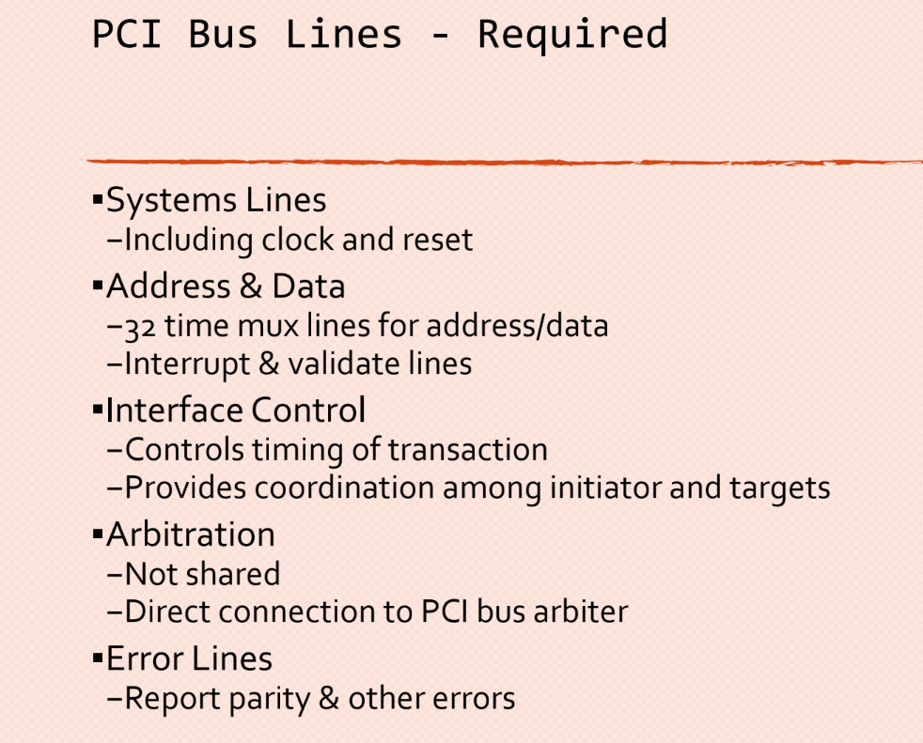

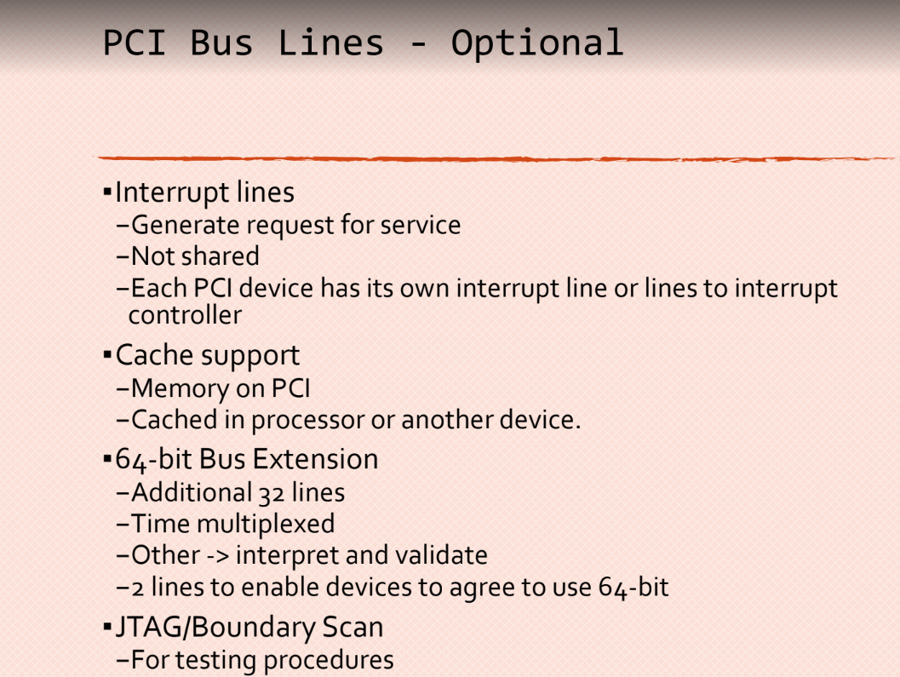

Q.System bus:

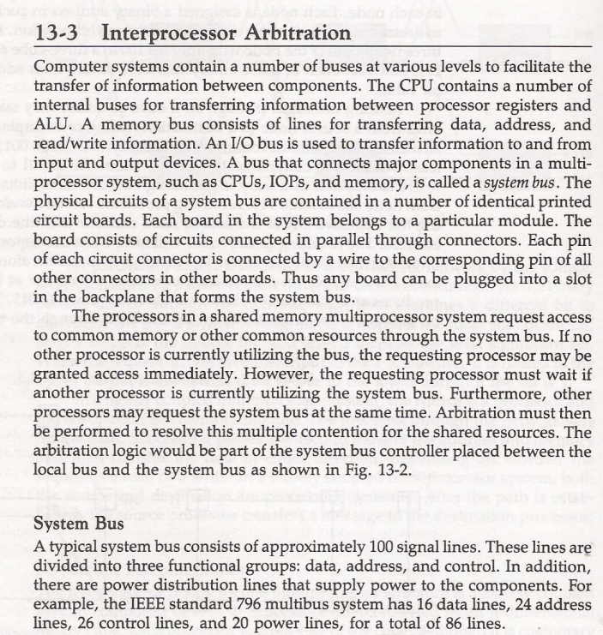

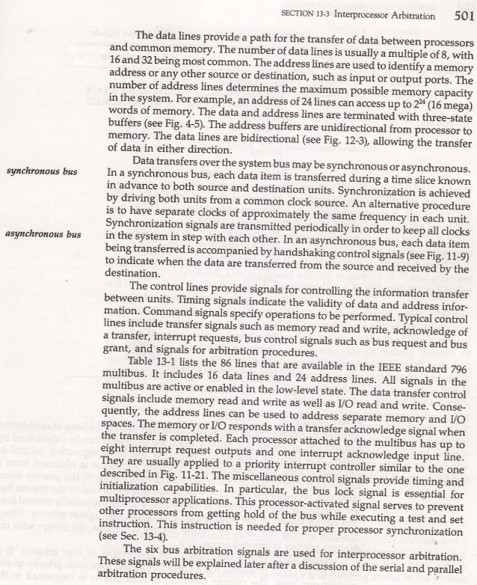

Serial bus arbiter:

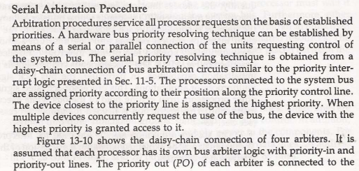

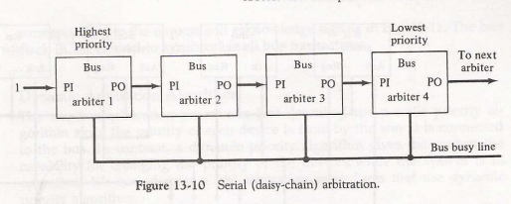

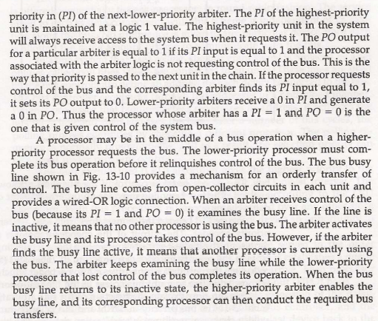

Parallel arbiter:

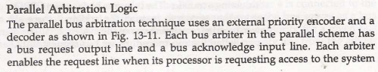

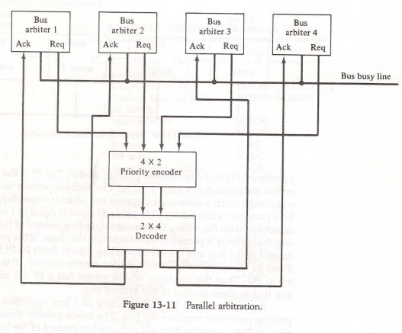

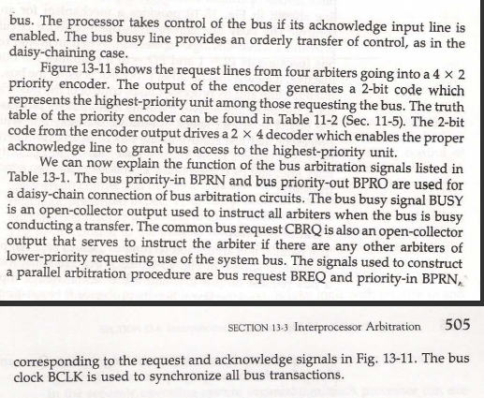

Q.SCSI

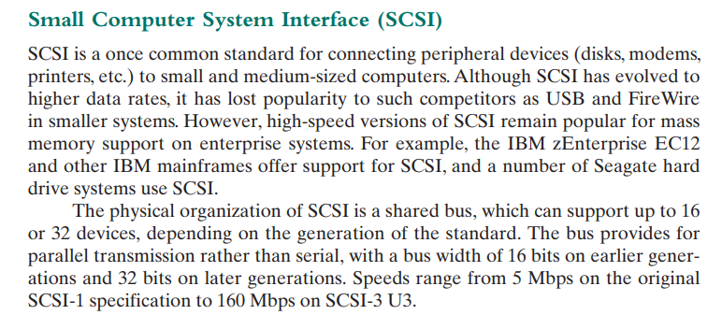

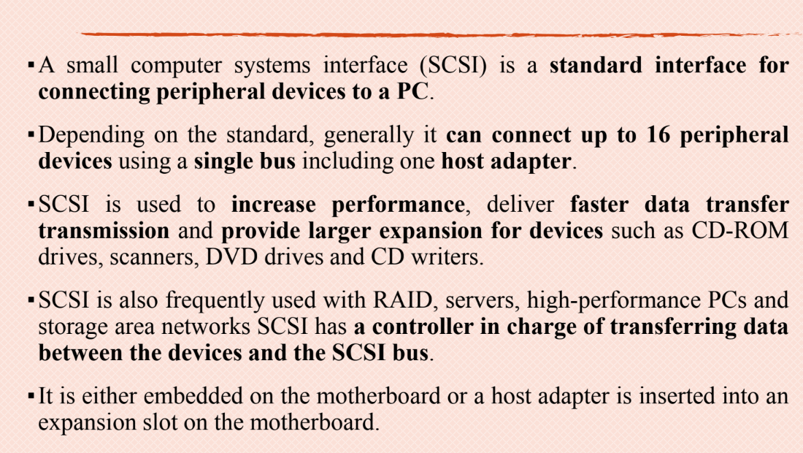

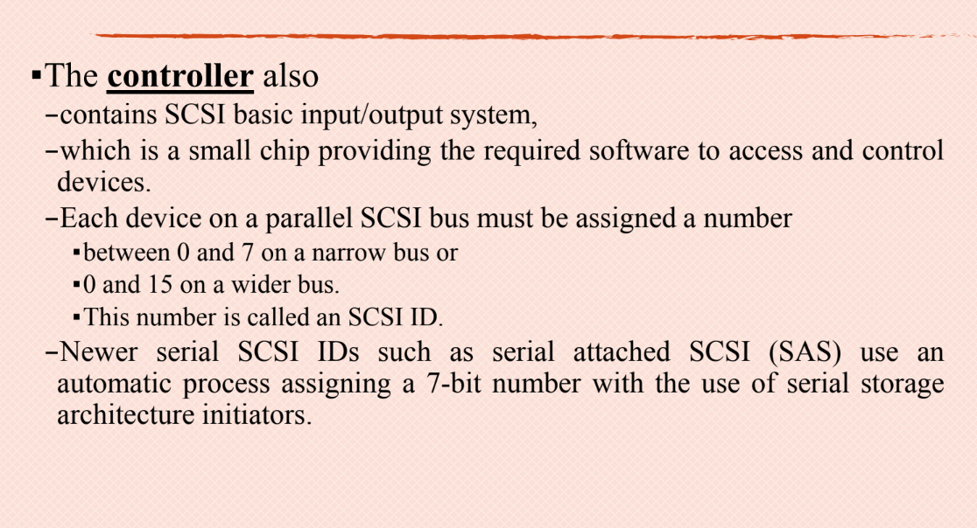

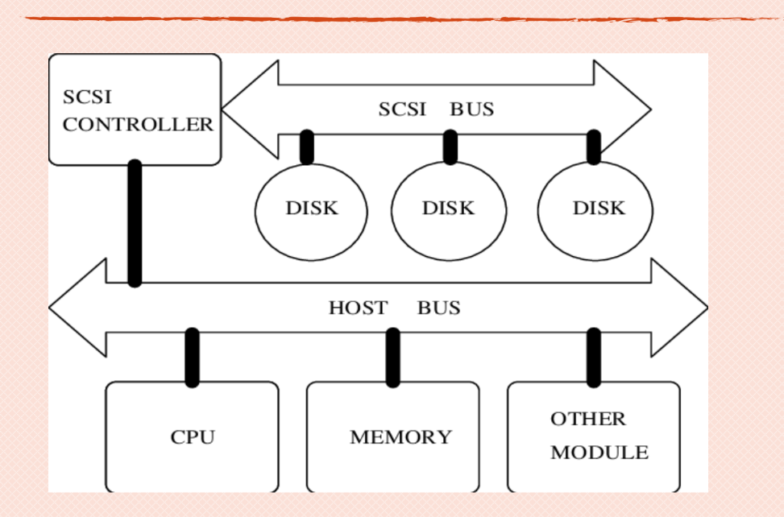

Micro ops

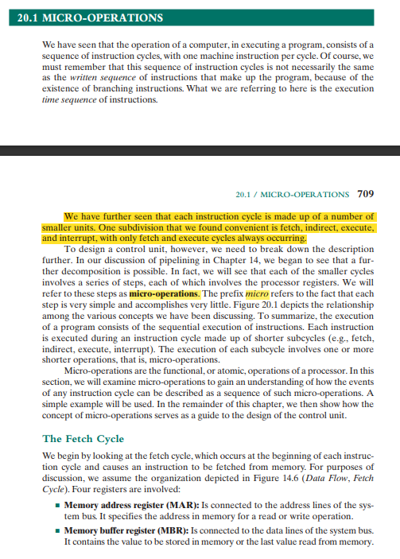

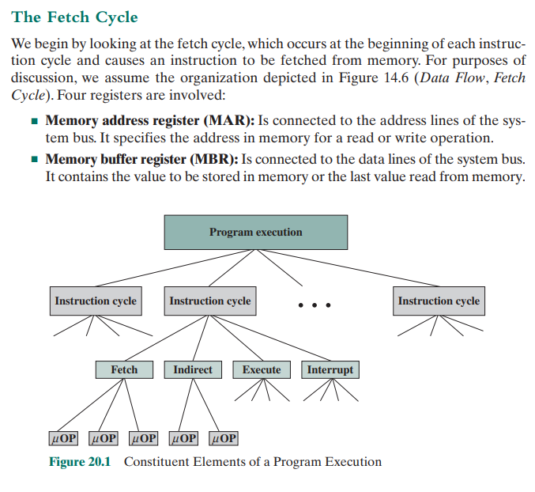

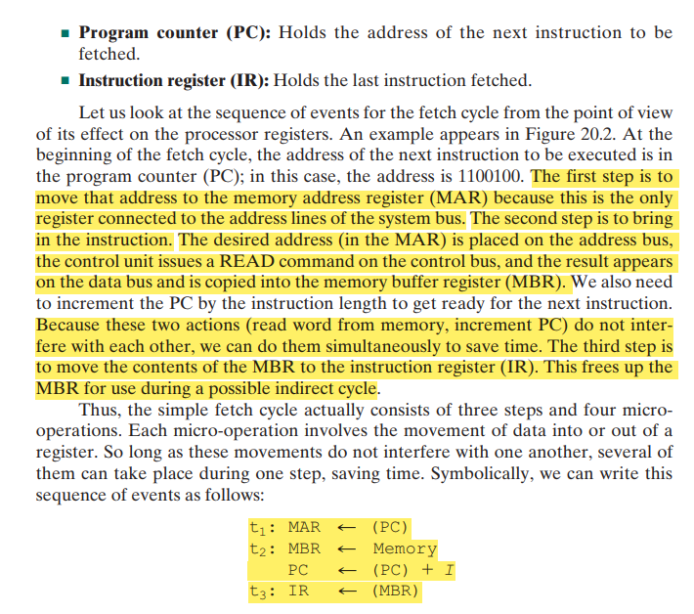

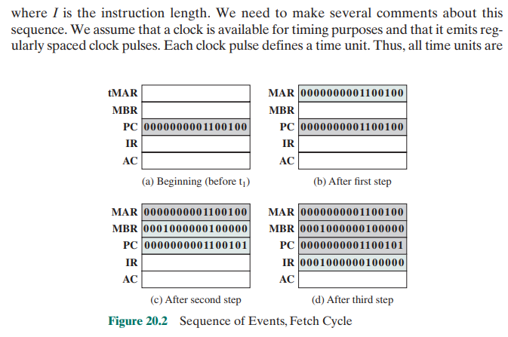

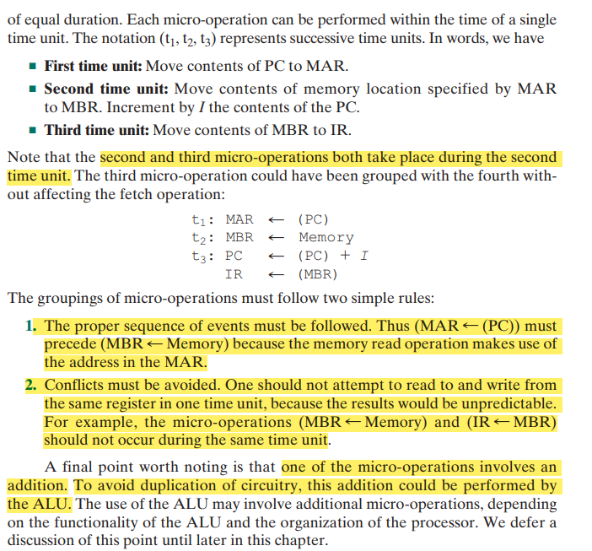

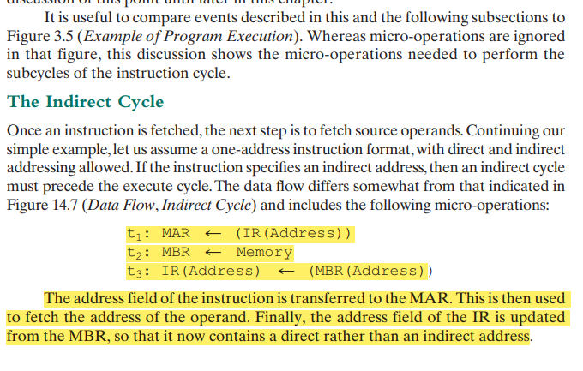

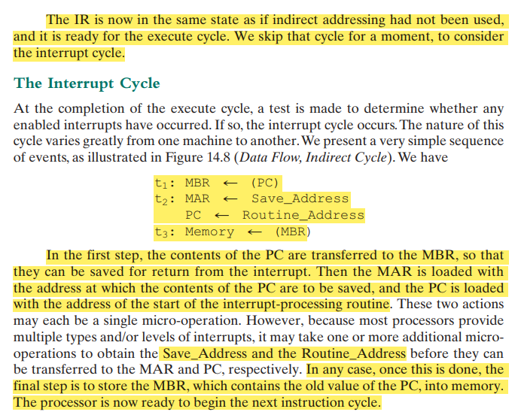

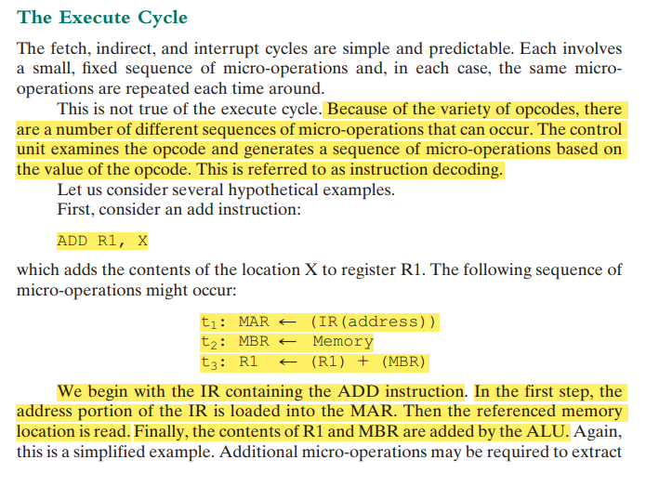

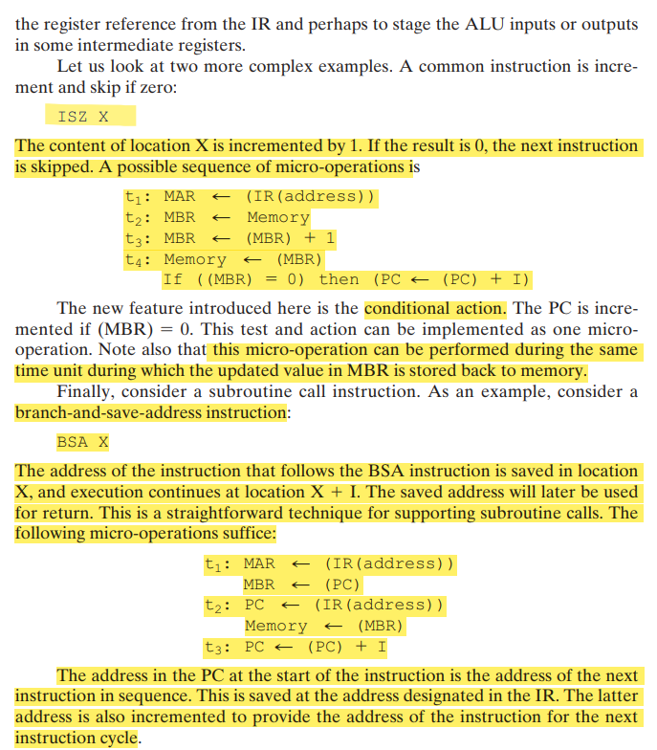

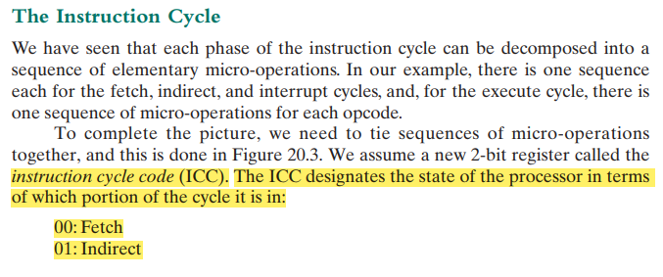

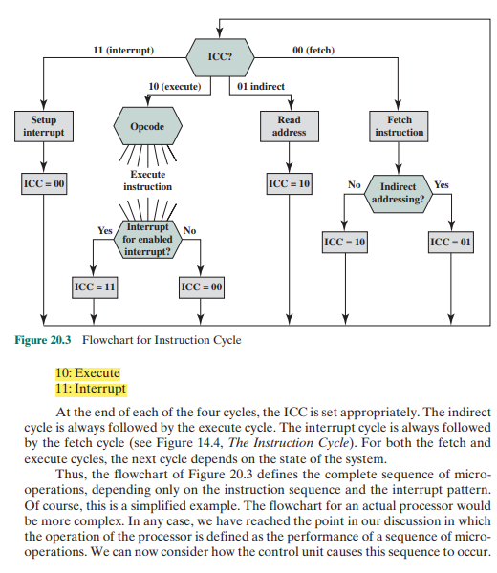

1.explain data paths and control signals needed for the functioning of the control unit.

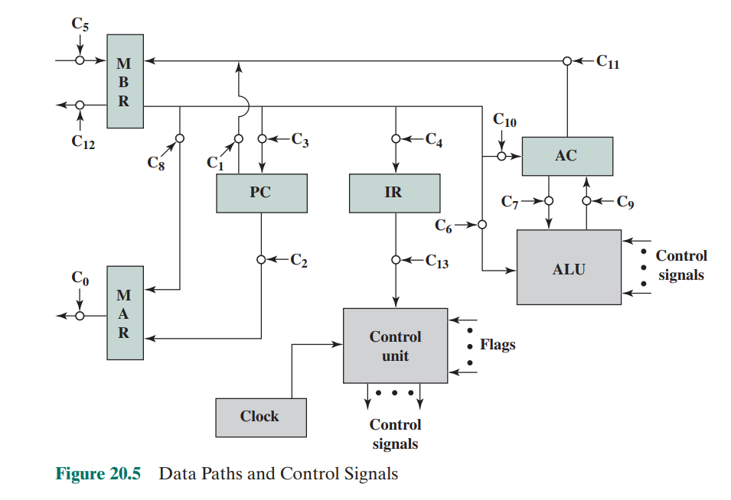

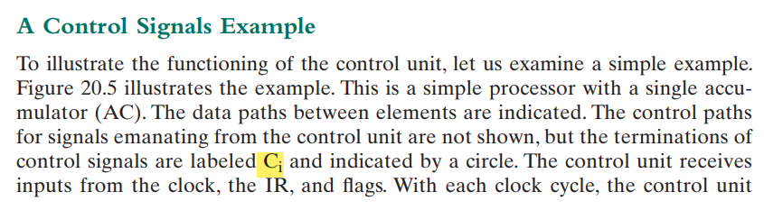

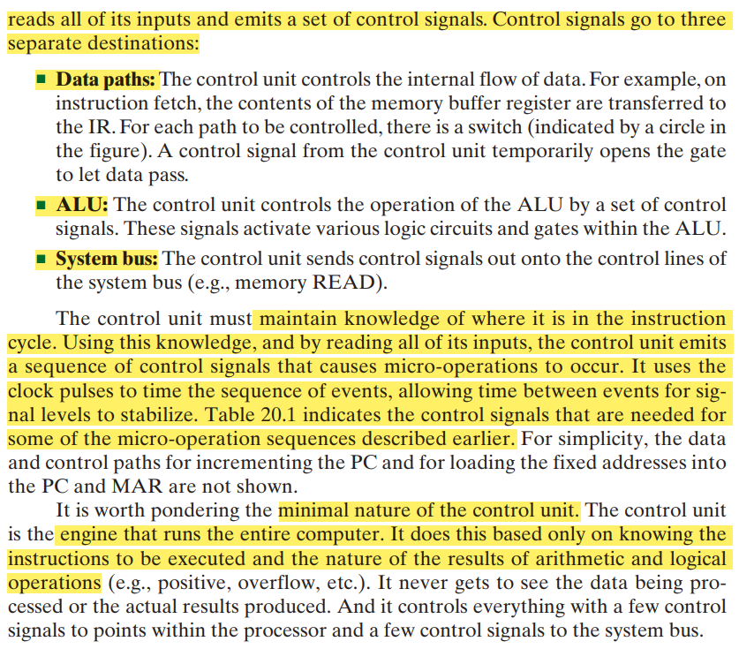

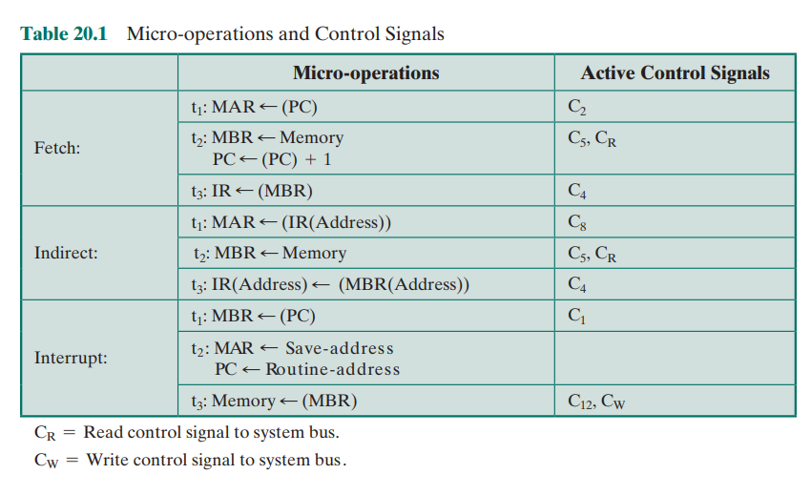

2. ADD R1 X

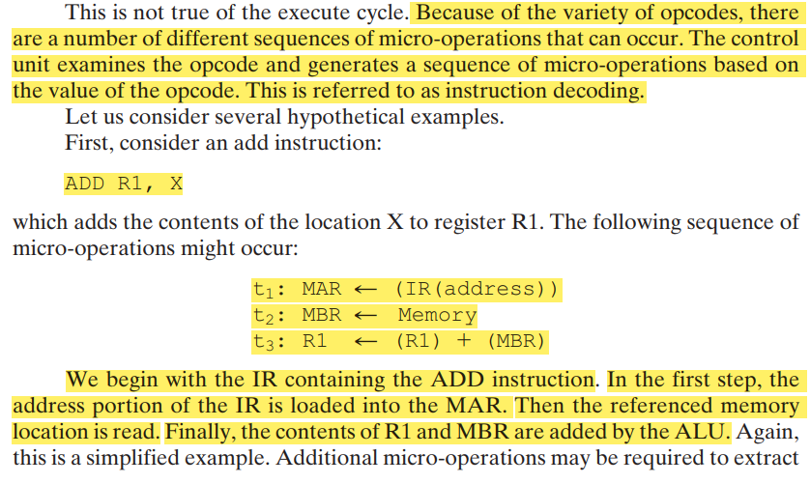

3.With a diagram explain how the control unit interacts with other elements of the cpu

Similar to prev?

Q)Hardwired implementation of the control unit ?

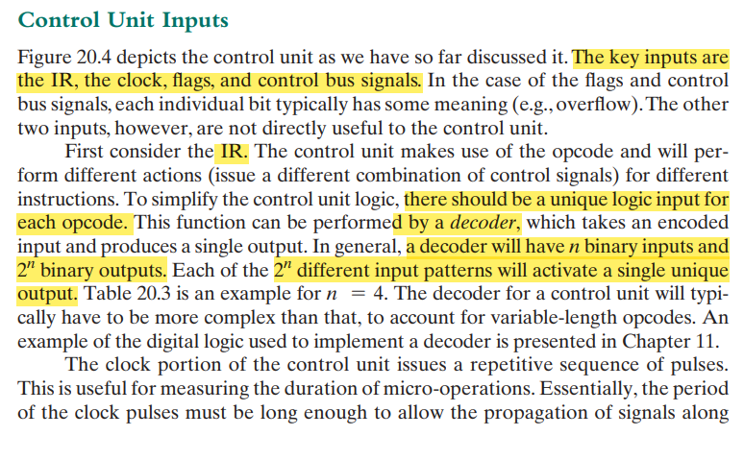

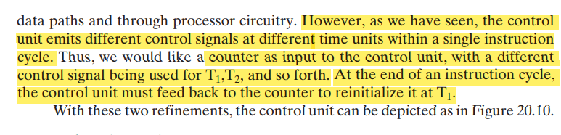

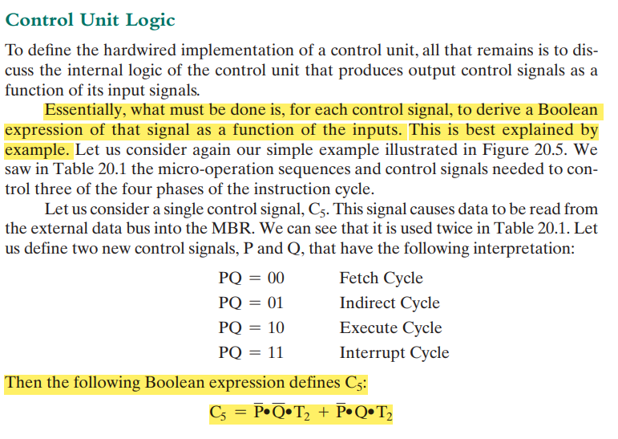

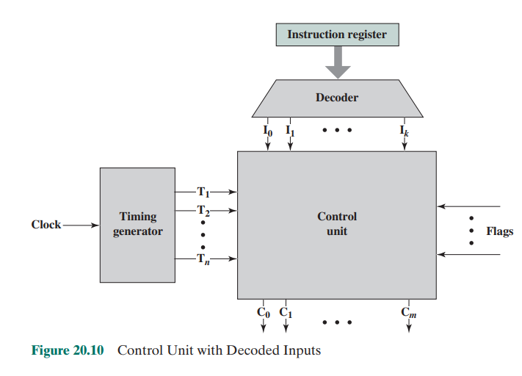

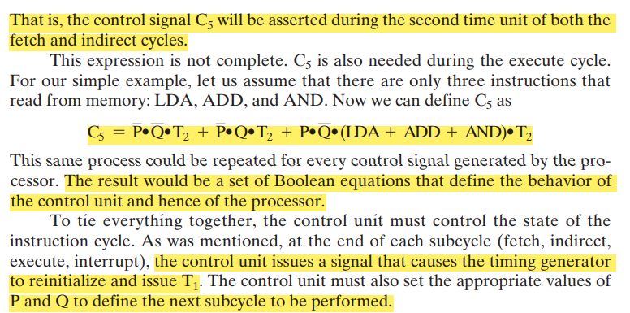

Q)Horizontal micro instruction?

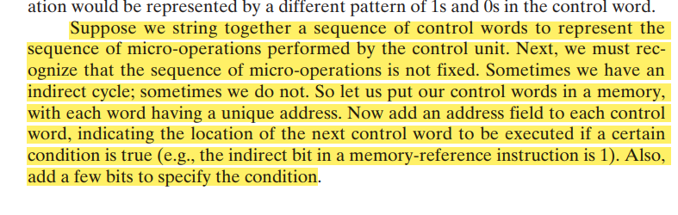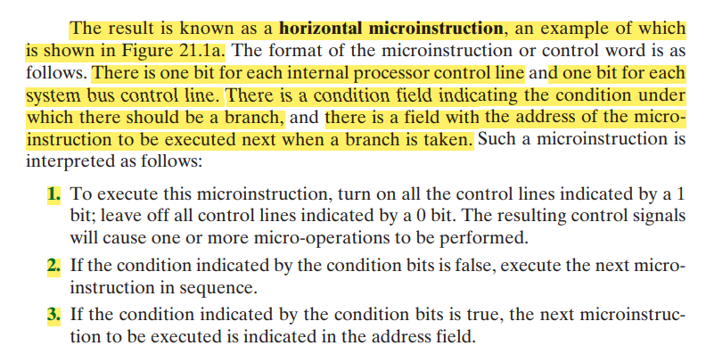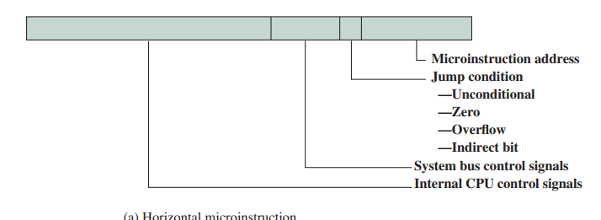

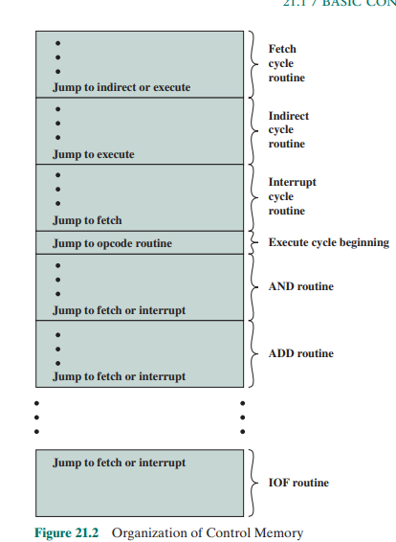

Q)Micro-program?

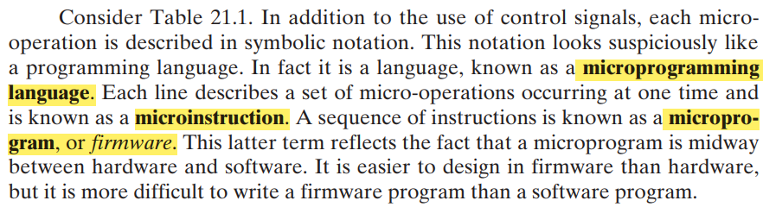

Q)Micro-instruction?

Each line describes a set of micro-operations occurring at one time and is known as a microinstruction.

Q)Vertical microinstruction?

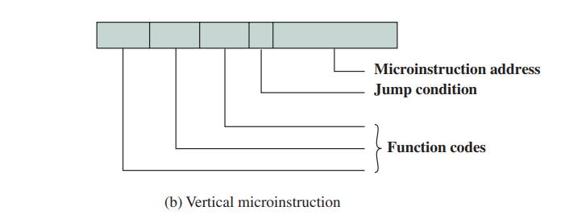

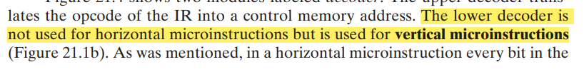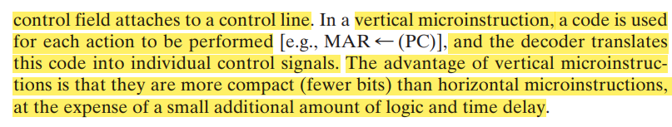

Q)Working of a microcontroller unit?

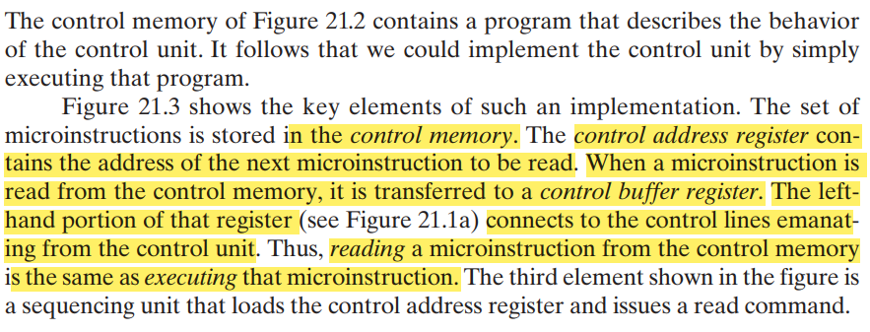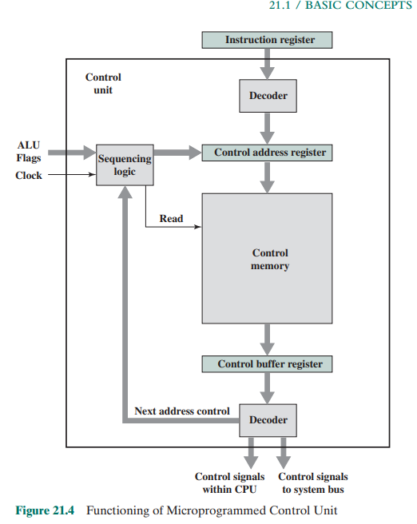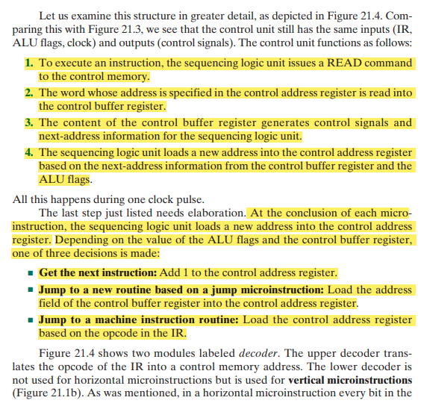

Q)Advantages and disadvantages of microprogrammed architecture

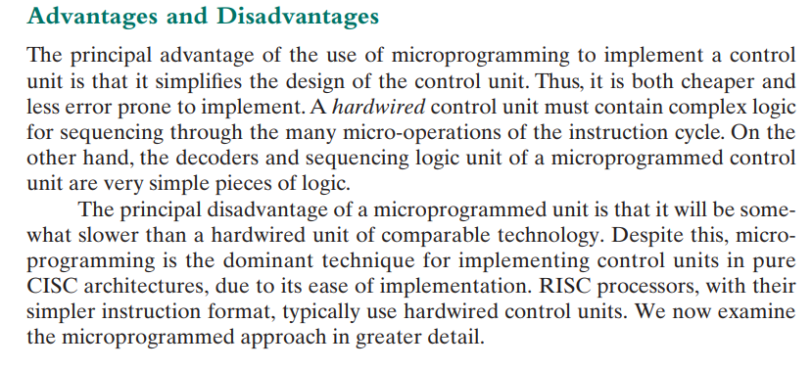

Q)Wilkes control unit?

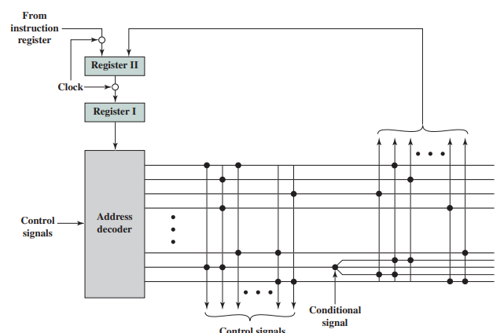

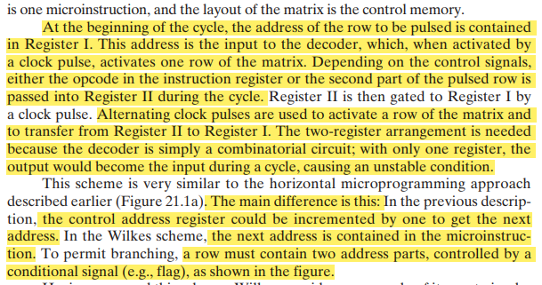

Q)Microinstruction sequencing ?

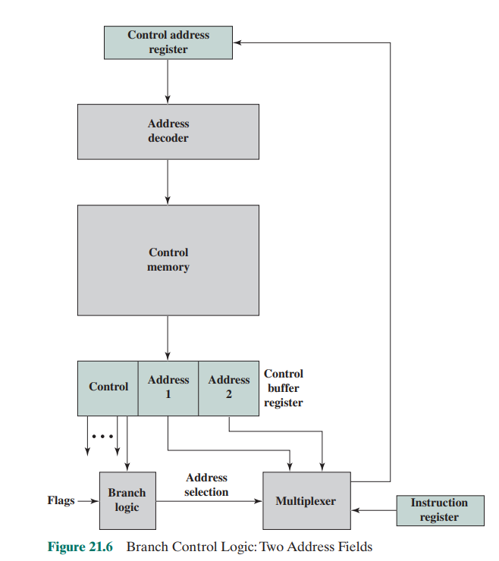

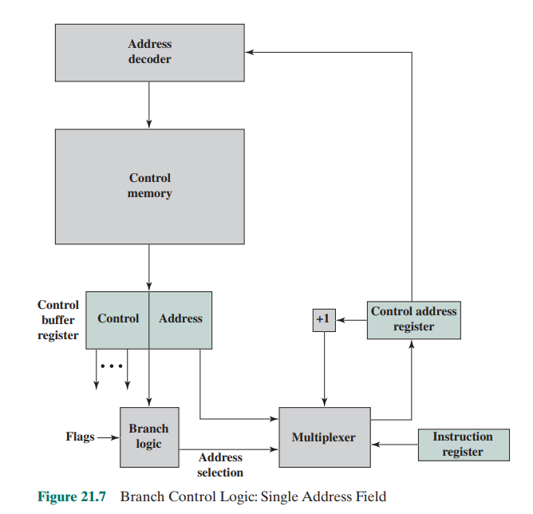

The simplest approach is to provide two address fields in each microinstruction. Figure 21.6 suggests how this information is to be used. A multiplexer is provided that serves as a destination for both address fields plus the instruction register.

Based on an address-selection input, the multiplexer transmits either the opcode

or one of the two addresses to the control address register (CAR). The CAR is

subsequently decoded to produce the next microinstruction address. The addressselection signals are provided by a branch logic module whose input consists of control unit flags plus bits from the control portion of the microinstruction.

Although the two-address approach is simple, it requires more bits in the

microinstruction than other approaches. With some additional logic, savings can be

achieved. A common approach is to have a single address field (Figure 21.7). With

this approach, the options for next address are as follows:

this approach, the options for next address are as follows:

■ Address field

■ Instruction register code

■ Next sequential address

The address-selection signals determine which option is selected. This approach

reduces the number of address fields to one. Note, however, that the address field

often will not be used. Thus, there is some inefficiency in the microinstruction coding

scheme.

Another approach is to provide for two entirely different microinstruction

formats (Figure 21.8). One bit designates which format is being used. In one

format, the remaining bits are used to activate control signals. In the other format, some bits drive the branch logic module, and the remaining bits provide

the address. With the first format, the next address is either the next sequential

address or an address derived from the instruction register. With the second

format, either a conditional or unconditional branch is being specified. One

disadvantage of this approach is that one entire cycle is consumed with each

branch microinstruction. With the other approaches, address generation occurs

as part of the same cycle as control signal generation, minimizing control memory accesses

Q)Micro instruction encoding?

